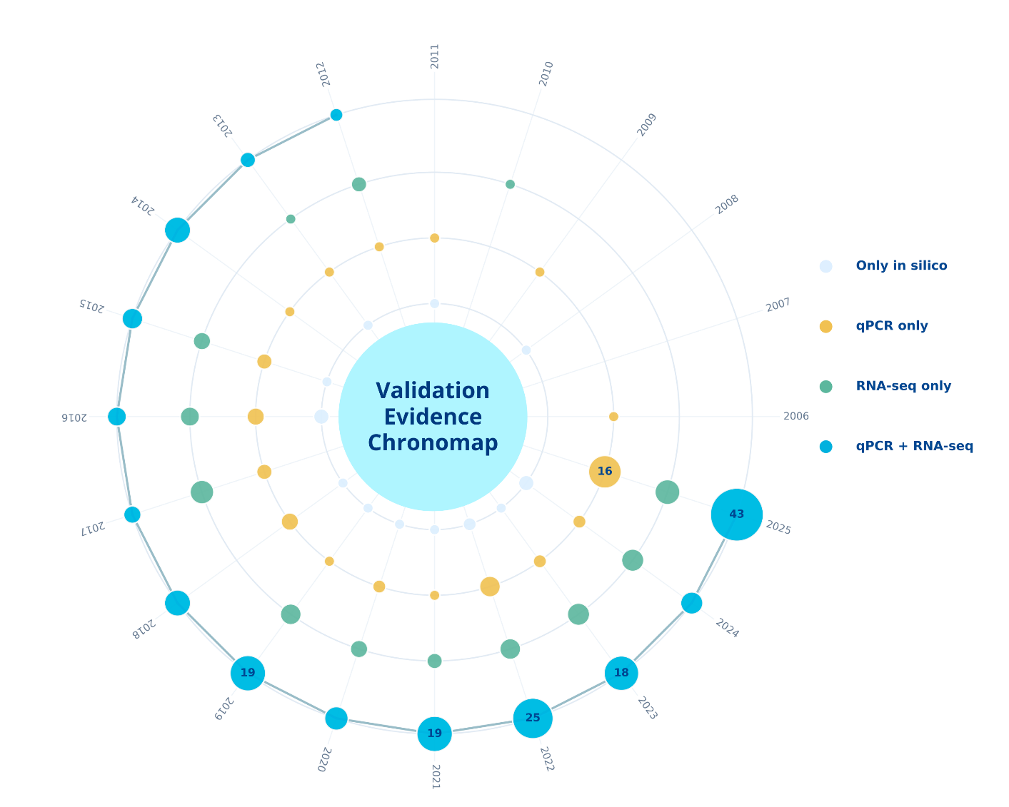
Figure 11. Validation evidence radial chronomap (2000-2025). The innermost ring represents the only in-silico studies, while the outermost ring shows the gradual increase in experimental validation of genome-wide gene family studies over time. Dot size indicates the number of studies in a particular year. Dot color represents the type of validation.

